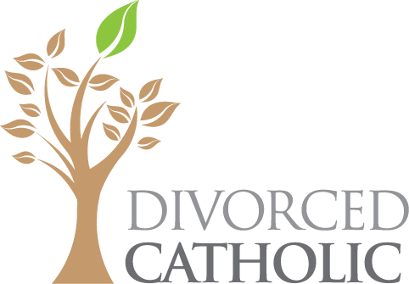

Certificate of Completion

RECOVERING FROM DIVORCE PROGRAM

John Doe
September 20, 2016

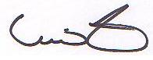
This certifies that the person name on this certificate has completed the Recovering from Divorce Program.

________________________ ________________________
Vince Frese Name
Program Creator Facilitator

